**JOB POSITIONING**

**TABLE JOB POSITIONS**

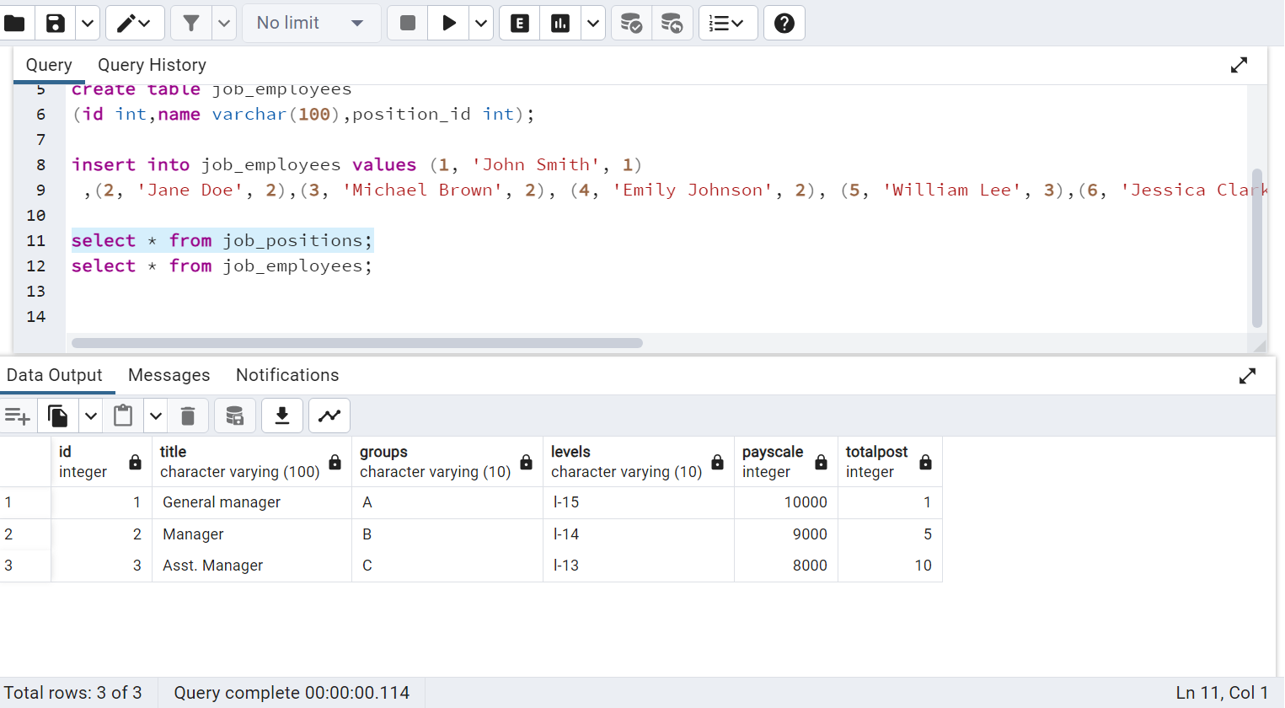

**EMPLOYEE TABLE**

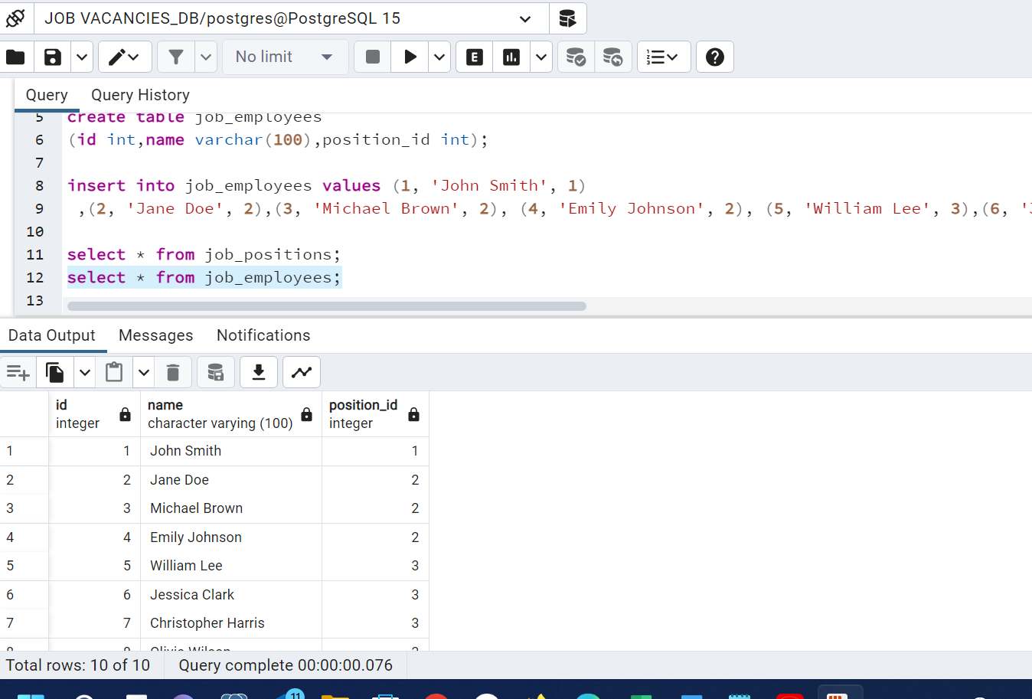

**JOIN WITH GENERATE SERIES**

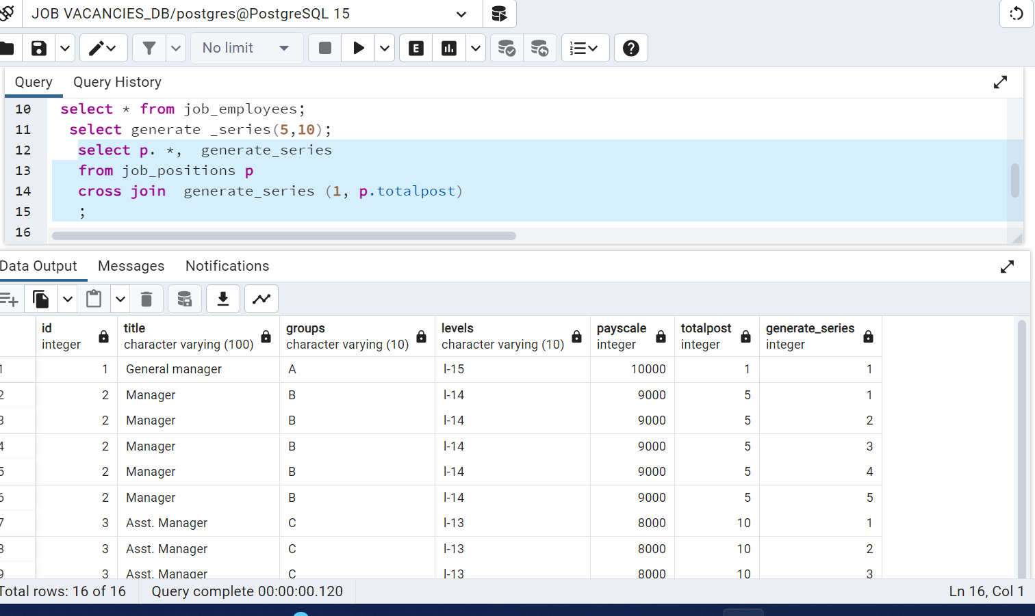

**CREATE ROW NUMBER job_employees**

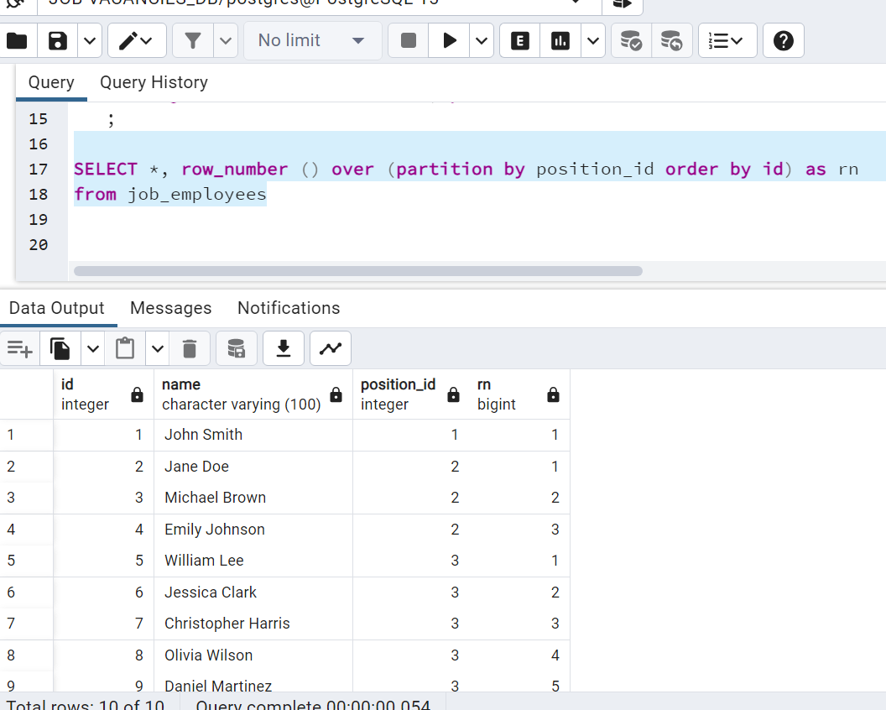

**Joining the job_position and employee_position**

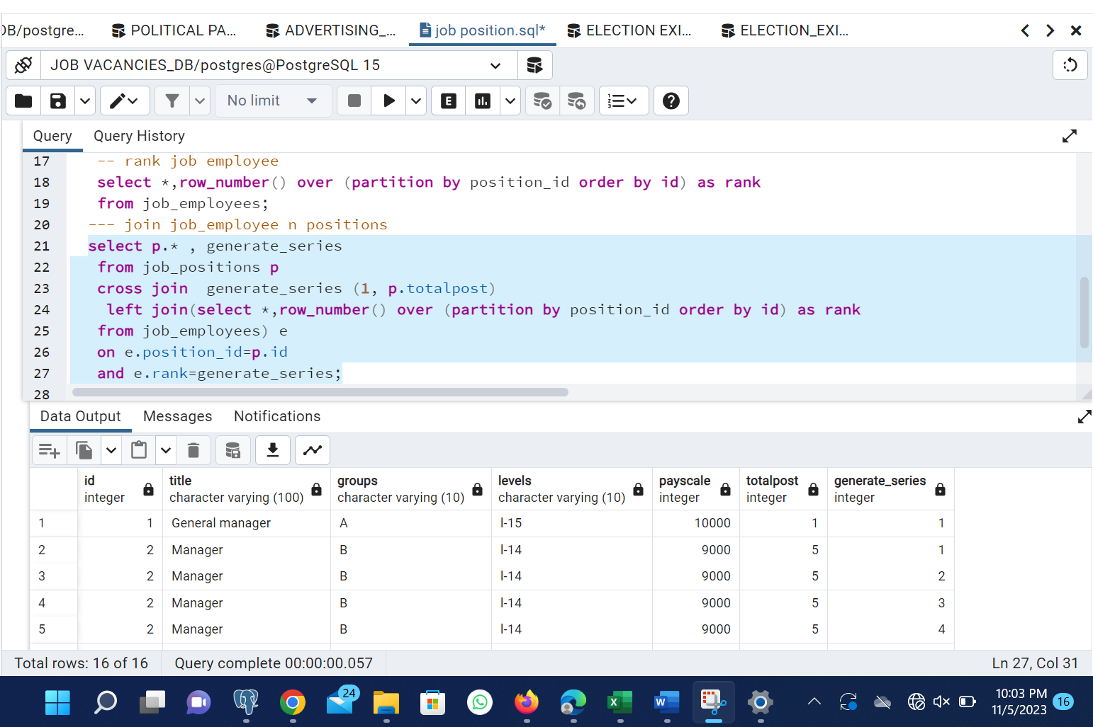

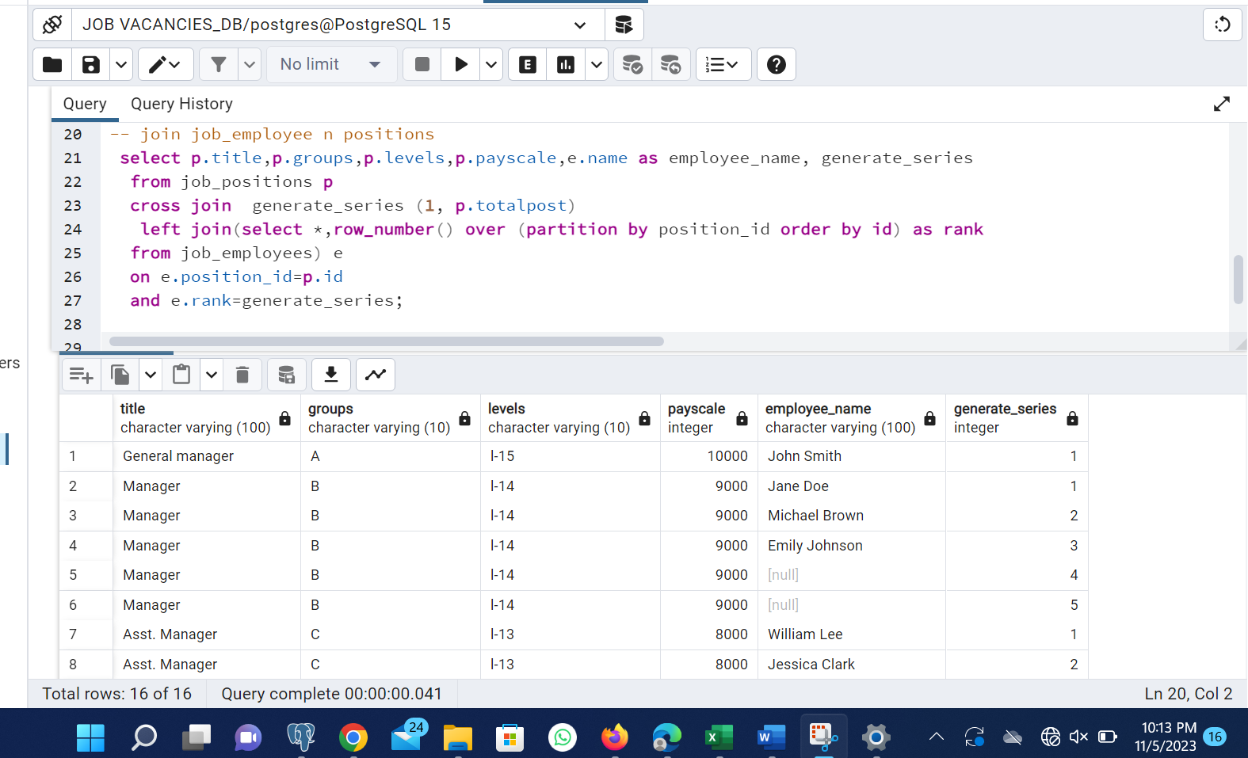

**REPLACE NULL WITH VACANT**

